**1btn becomes more powerful with multi-task functionality !**

While it is true that 1btn is meant to be simple and minimalistic interface to perform just one task upon single click; we have been working towards making it versatile device which could do more than one task without compromising its simplicity. And “time of the day” seems to be logical to define multiple tasks for one single button while there could be other alternatives like single or double click and long press.

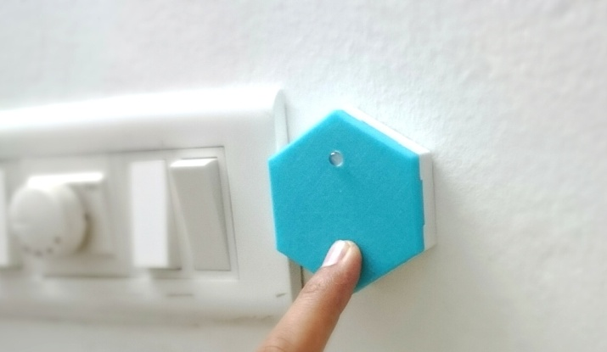However, when we keep simplicity at the center of 1btn, single-double clicks or long presses sound be confusing from a general user’s point of view. So we decided that “time of the day” indeed is a good differentiator for 1btn triggers and now we are ready with this functionality.

Good news is: you have to do nothing to avail this functionality. No firmware update, no hardware change, none of that. All you could do is: while using “Add new button”, use the same MAC ID as that of existing button. This will create another copy of the button which will have its own nick name and time window, task details, etc. Just that it will represent a common hardware, which now would have two or more tasks assigned.

One of the use cases where this powerful function could be helpful is, when for example, you setup a single 1btn device (hardware) to send different text messages during the day. Say, you want to send ‘Good Morning’ during 07:00 am to 11:59 am and then send ‘Good Afternoon’ during 12:00 noon till 04:30 pm. You can further add one more task to send ‘Good Night’ for another window. And thus you can add as many tasks as you want.

Just remember that, when 1btn is triggered, if there are two or more tasks that satisfy time window condition, only one task would get executed. This most probably could be the first task you have created with given 1btn. Another use case where this functionality could be put to use is sending time based reminders to someone. For instance, with single click function, I could send a text message to my grandmother and remind her to take her medicine everyday three times. Now, with this time based multi-tasking, I can not only send her reminder message but can now add specifics such as which medicine to take in the morning and which in the night.

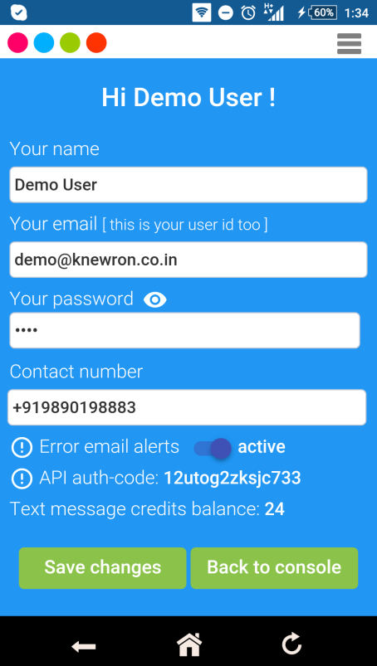Time window comparison happens till next minute, which means if you give one task time window as 9 AM to 6 PM & next as 6:01 to 8 PM; then don’t worry, your previous task will be active till 6:00:59 PM.

Apart from this powerful feature, we also have enabled additional functionality in user profile. We found that some users struggle with configuration and debugging when 1btn blinks red as it is difficult for them to figure out what happened. To help with this, you can enable error email alerts from your 1btn profile page.

When this option is enabled, you will get an email alert on your registered email id (which is your login email too), whenever button action fails. This email may contain error details which could be useful for you to debug / adjust configuration settings correctly.

We have come a long way since the initial launch and now we are working with a few bigger and complex use cases in B2B segments using 1btn. And we are eager to know how are you using your 1btn, where has it helped and how do you think we can collaborate together to make things smarter while keeping them simpler!

Do send your feedback, contact us for collaboration or just say hi on 1btn@knewron.co.in.